Environment Overview
The Novant IdentityIQ platform will encompass Production (PROD), Disaster Recovery (DR), Quality Assurance (Test) and Development (DEV) environments.

Hardware Summary
The following table summarizes the hardware needs by environment.
Product Requirements | # Servers | Memory | Storage | CPU | O/S (64Bit Required) | Virtual/  Physical | Notes
DEV
Database Tier | 1 | 16GB | 100GB | 6 Cores (RAC) | Windows Server 2022 | Virtual | MS SQL Server 2022
Application Tier (2Task) | 2 | 16GB | 40GB | 4 Cores | Windows Server 2022 | Virtual | Apache Tomcat 9.0, JDK 17
Application Tier (1UI) | 1 | 16GB | 40GB | 4 Cores | Windows Server 2022 | Virtual | Apache Tomcat 9.0, JDK 17
Connector server | 1 | 8GB | 40GB | 2 Cores | Windows Server 2022 | Virtual | IQservice

Product Requirements | # Servers | Memory | Storage | CPU | O/S (64Bit Required) | Virtual/  Physical | Notes
TEST
Database Tier | 1 | 16GB | 100GB | 6 Cores (RAC) | Windows Server 2022 | Virtual | MS SQL Server 2022
Application Tier (2Task) | 2 | 16GB | 40GB | 4 Cores | Windows Server 2022 | Virtual | Apache Tomcat 9.0, JDK 17
Application Tier (1UI) | 1 | 16GB | 40GB | 4 Cores | Windows Server 2022 | Virtual | Apache Tomcat 9.0, JDK 17
Connector server | 1 | 8GB | 40GB | 2 Cores | Windows Server 2022 | Virtual | IQservice

Product Requirements | # Servers | Memory | Storage | CPU | O/S (64Bit Required) | Virtual/  Physical | Notes
PROD
Database Tier | 1 | 64GB | 320GB | 8 Cores (RAC) | Windows Server 2022 | Virtual | MS SQL Server 2022
Application Tier (4Task) | 4 | 64GB | 40GB | 8 Cores | Windows Server 2022 | Virtual | Apache Tomcat 9.0, JDK 17
Application Tier (4UI) | 4 | 16GB | 40GB | 4 Cores | Windows Server 2022 | Virtual | Apache Tomcat 9.0, JDK 17
Connector server | 1 | 8GB | 40GB | 4 Cores | Windows Server 2022 | Virtual | IQservice

Product Requirements | # Servers | Memory | Storage | CPU | O/S (64Bit Required) | Virtual/  Physical | Notes
DR
Database Tier | 1 | 64GB | 320GB | 8 Cores (RAC) | Windows Server 2022 | Virtual | MS SQL Server 2022
Application Tier (4Task) | 4 | 64GB | 40GB | 8 Cores | Windows Server 2022 | Virtual | Apache Tomcat 9.0, JDK 17
Application Tier (4UI) | 4 | 16GB | 40GB | 4 Cores | Windows Server 2022 | Virtual | Apache Tomcat 9.0, JDK 17
Connector server | 1 | 8GB | 40GB | 4 Cores | Windows Server 2022 | Virtual | IQservice

Note: If ServiceNow is being considered as centralized platform to handle all user requests, the number of UI servers can be reduced.

Disaster Recovery Summary

Database Replication Overview
- Identify the Primary Database (PROD):
Designate a primary database that serves as the main source where all data changes originate.
- Configure Replica Databases (DR):
Set up one DR database to receive updates from the primary database.
- Capture Data Changes:
Modifications like inserts, updates, or deletions in the primary database are typically monitored using transaction logs or change data capture (CDC) mechanisms.
- Transfer Changes to Replicas:
The recorded changes are transmitted to DR database in real-time or at scheduled intervals over the network.
- Apply Changes on Replicas:
DR database applies the received changes to stay synchronized with the primary database, maintaining data consistency.
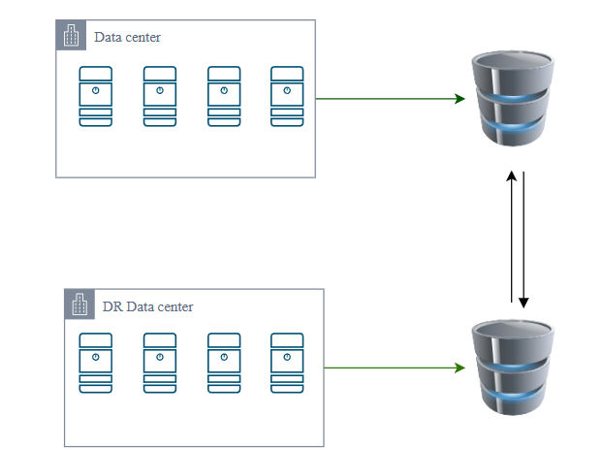

Load Balancing
In an active-standby load balancing configuration, the primary (active) load balancer manages all incoming traffic under normal operating conditions. Meanwhile, the secondary (standby) load balancer remains idle, but fully synchronized and ready to take over instantly if the primary fails.

Load Balancers Set-up
- Primary Load Balancer (Active):
  - Directs and distributes incoming traffic to the application servers in the primary data center.
  - Continuously checks the health and performance of both servers and network infrastructure.
- Secondary Load Balancer (Standby):
  - Does not handle traffic during normal operations.
  - Regularly syncs with the active load balancer to stay current with configurations and system state.

Failover Process
- If the primary load balancer experiences a failure or critical issue, a failover is initiated.
- The secondary load balancer automatically becomes active and begins routing traffic, ensuring minimal service interruption.

Failback Process
- After the primary load balancer is restored and validated as healthy, traffic is redirected back to it.
- The secondary load balancer reverts to standby mode, remaining ready for future failover needs.
This architecture enhances system availability and resilience by ensuring that a fully configured backup load balancer is always on standby to maintain seamless service continuity in the event of a failure.

The simplified flow diagram illustrates the data center to disaster recovery (DC-DR) strategy

